Throughput RAM Flash_procedure

# Index

Contenido

1. Index 1

2.1 Table of Figures 1

Throughput and Flash and RAM measurement 2

1 Memory Analysis 2

2 Thread Analysis 3

## 2.1 Table of Figures

Figure 13 Eclipse Compilation Output 2

Figure 14 ELF analysis 2

Figure 15 Threads 3

Figure 16 Display Thread. 4

Figure 17 Input Capture Thread. 4

Figure 18 ACD Thread. 4

Figure 19 Thread for touch display events 5

Figure 20 Complementary Display Thread 5

## Throughput and Flash and RAM measurement

### 1 Memory Analysis

The Throughput analysis was done when the code achieved a final state.

The eclipse compilation output is shown in the Figure 13.

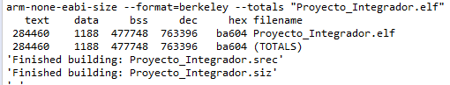

Figure 13 Eclipse Compilation Output

Besides, The binary was analyzed using the tool *ELF Parser*, the parser gave the results depicted in the Figure 14.

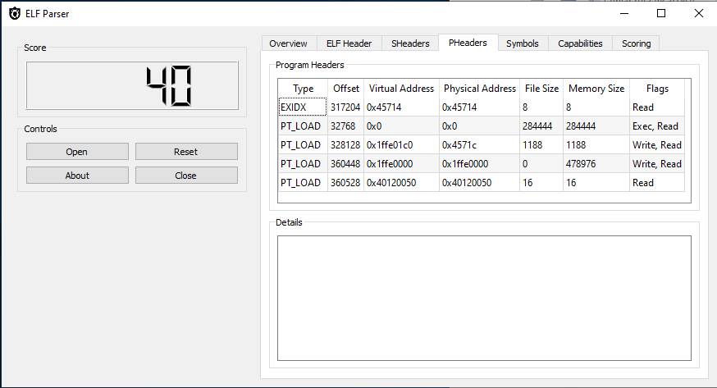

Figure 14 ELF analysis

As a result, the ELF Parser is reporting the same results but it provides more details of the memory distribution. The following table presents the memory distribution of the binary.

|  |  |
| --- | --- |
| Section | Size |
| program/executable | 284,444 |
| Ram memory | 1,188 |
| Rom memory | 478,976 |
| Debug Information | 4,901,420 |
| Other | 24 |
| Total | 5,666,052 |

### Thread Analysis

For the thread analysis was used eclipse in debug mode. In the Figure 15 are shown 6 threads.

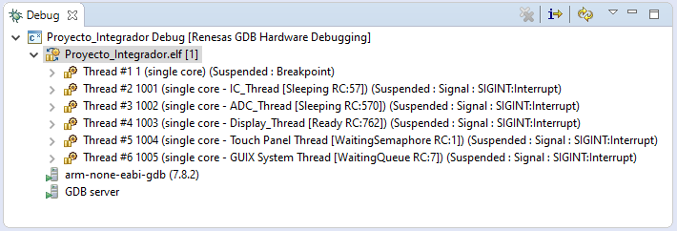

Figure 15 Threads

The Thread #1 is the Display Thread (Depicted in Figure 16).

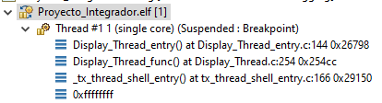

Figure 16 Display Thread.

The Thread # 2 is for the Input Capture thread (Depicted in Figure 17).

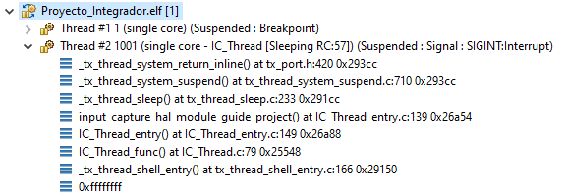

Figure 17 Input Capture Thread.

The Thread #3 is for the ADC thread (depicted in Figure 18).

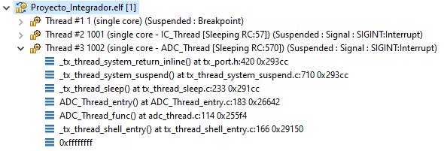

Figure 18 ACD Thread.

The Thread #4 is the same instance as Thread #1 the difference is that the Thread #1 was used to suspend the program and get the Thread information (debug mode).

The Thread #5 is another thread for the display. This thread is listening the events from the touch panel (Depicted in Figure 19).

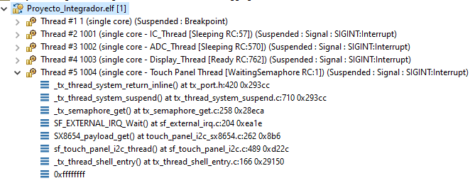

Figure 19 Thread for touch display events

The Thread #6 is another thread necessary for the display in order to paint the widgets (Depicted in Figure 20).

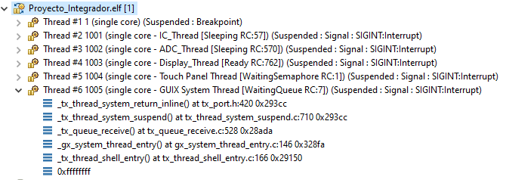

Figure 20 Complementary Display Thread